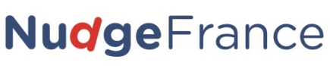
NudgeChallenge Registration Form
  - Complete this document and send it to nudgefrance@gmail.com before September 30th!
Reminder: videos will have to be sent by October 31st - Extended deadline November 15th! See the PowerPoint document for instructions.
WE WANT TO PARTICIPATE TO (1, or 2, or both):____
❶The Best Presentation Award (in French only) ❷The Video Contest (international)

School/University name and address:
Example: University of Michigan, 503 Thompson Street, 48109 Ann Arbor, MI, USA.

Name, position and email address of your programme tutor:
Example: John Bennett, Director of the University’s Business Department, jbennett@uofm.com

Team leader’s name, school programme and email address:
Example: Sara Bradford, International Business MSc, sbradford@uofm.com

Team members’ names, school programme and email addresses:

Your Team Name:
Example: The Ann Arbor Behaviouralists

Your Nudge Project topic and challenge:
Example: Water savings. How to get people to use less water while showering?

